**Azure AI Document Intelligence**

Form Recognizer is now **Azure AI Document Intelligence.**

Azure AI Document Intelligence is a cloud-based [Azure AI service](https://docs.azure.cn/en-us/ai-services/?view=doc-intel-4.0.0) that enables you to build intelligent document processing solutions. Massive amounts of data, spanning a wide variety of data types, are stored in forms and documents. Document Intelligence enables you to effectively manage the velocity at which data is collected and processed and is key to improved operations, informed data-driven decisions, and enlightened innovation.

**Models**

**General extraction models**

General extraction models enable text extraction from forms and documents and return structured business-ready content ready for your organization's action, use, or development.

*In Azure AI Document Intelligence, three of the prebuilt models are for general document analysis:*

* *Read*
* *General document*
* *Layout*

**Prebuilt models**

Prebuilt models enable you to add intelligent document processing to your apps and flows without having to train and build your own models.

*The other prebuilt models expect a common type of form or document:*

* *Invoice*
* *Receipt*
* *W-2 US tax declaration*
* *ID Document*
* *Business card*
* *Health insurance card*

**Custom models**

Custom models are trained using your labelled datasets to extract distinct data from forms and documents, specific to your use cases. Standalone custom models can be combined to create composed models.

* **Document field extraction models**

Document field extraction models are trained to extract labelled fields from documents.

[**Custom template**](https://docs.azure.cn/en-us/ai-services/document-intelligence/overview?view=doc-intel-4.0.0#custom-template) | Extract data from static layouts.

[**Custom composed**](https://docs.azure.cn/en-us/ai-services/document-intelligence/overview?view=doc-intel-4.0.0#custom-composed) | Extract data using a collection of models.

* **Custom classification models**

Custom classifiers identify document types before invoking an extraction model.

[**Custom classifier**](https://docs.azure.cn/en-us/ai-services/document-intelligence/overview?view=doc-intel-4.0.0#custom-classification-model) | Identify designated document types (classes) before invoking an extraction model.

**Development options**

**Read**

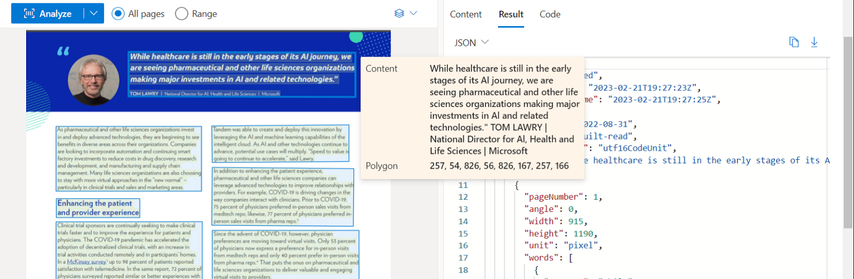

**Layout**

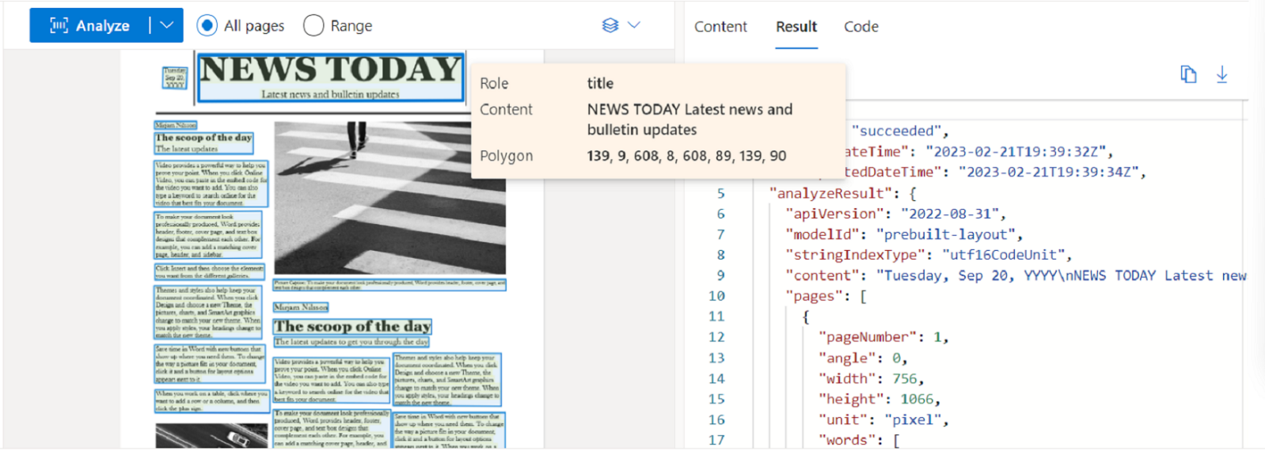

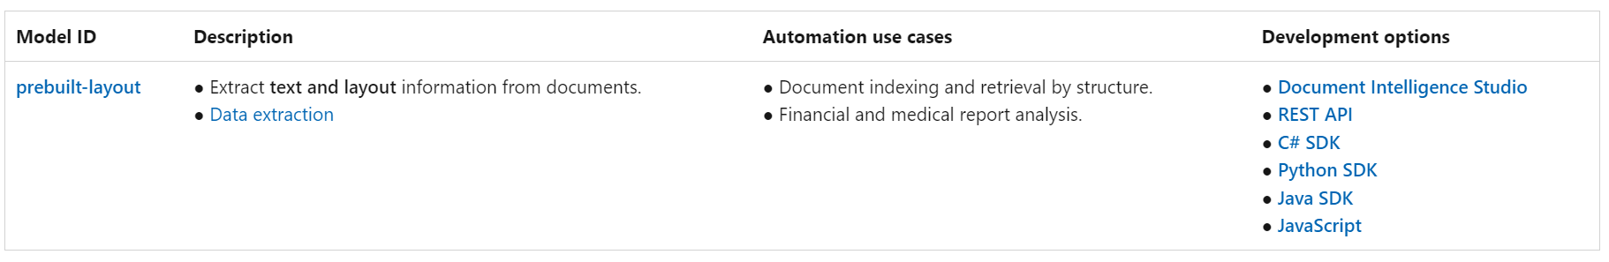

**Custom model overview**

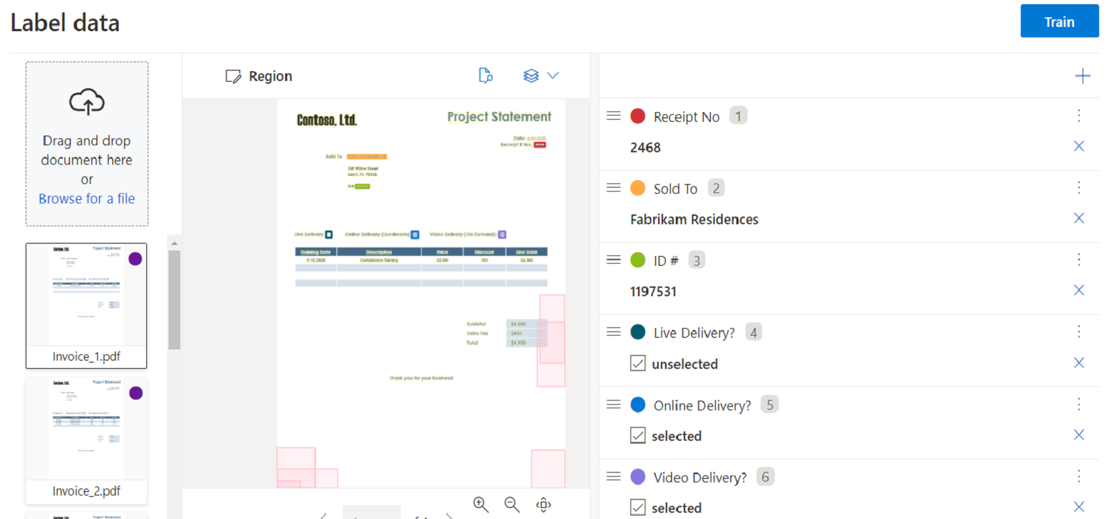

**Custom template**

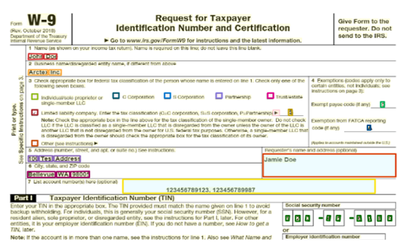

**Custom composed**

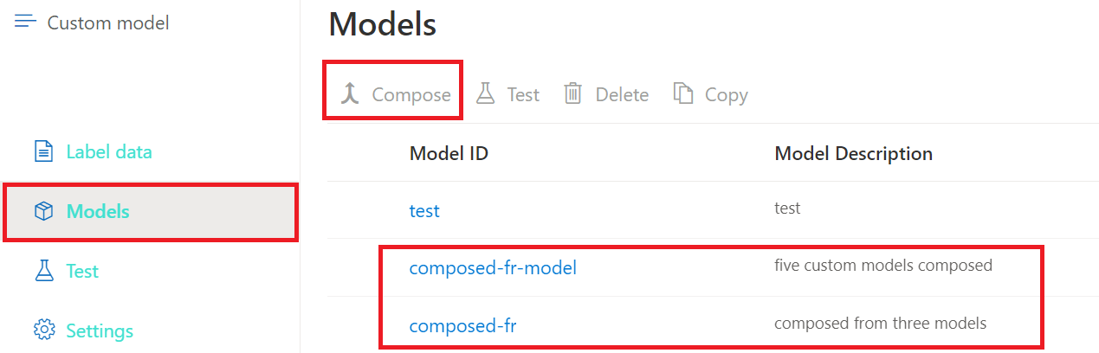

**Custom classification model**

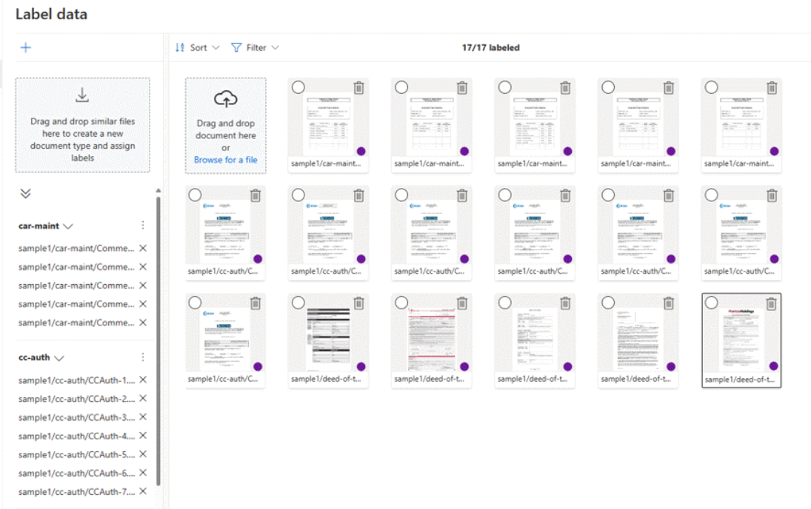

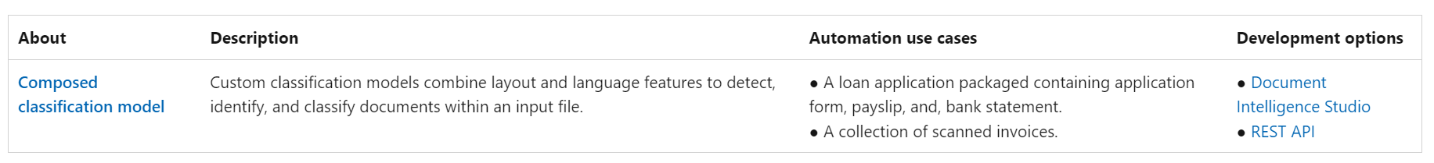

**Document Intelligence Studio**

Document Intelligence Studio is an online tool to visually explore, understand, train, and integrate features into your applications. You can easily extract key data from documents or create your own custom models with a no-code approach.

<https://formrecognizer.appliedai.azure.cn/studio>

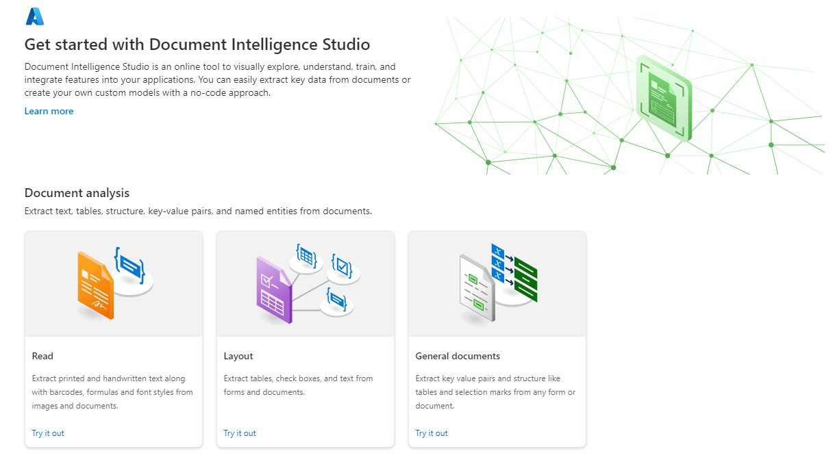

**Input requirements (v4)**

* Supported file formats:

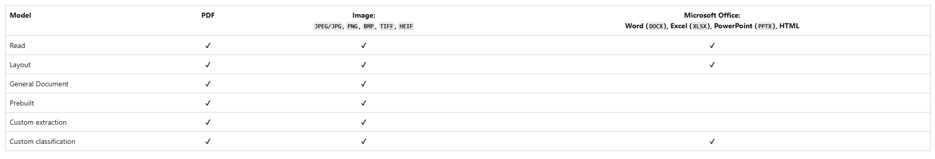

* For best results, provide one clear photo or high-quality scan per document.
* For PDF and TIFF, up to 2,000 pages can be processed (with a free tier subscription, only the first two pages are processed).
* The file size for analyzing documents is 500 MB for paid (S0) tier and 4 MB for free (F0) tier.
* Image dimensions must be between 50 pixels x 50 pixels and 10,000 pixels x 10,000 pixels.
* If your PDFs are password-locked, you must remove the lock before submission.
* The minimum height of the text to be extracted is 12 pixels for a 1024 x 768 pixel image. This dimension corresponds to about 8 point text at 150 dots per inch (DPI).
* For custom model training, the maximum number of pages for training data is 500 for the custom template model and 50,000 for the custom neural model.
  + For custom extraction model training, the total size of training data is 50 MB for template model and 1 GB for the neural model.
  + For custom classification model training, the total size of training data is 1 GB with a maximum of 10,000 pages. For 2024-11-30 (GA), the total size of training data is 2 GB with a maximum of 10,000 pages.

**How to Use Document Intelligence Studio and Azure to Extract a JSON file from a PDF**

**What You Will Need**

1. **Microsoft Azure Account**: If you don’t have one, you can sign up for a free account.
2. **Document Intelligence Studio:**Available as part of Azure AI services.
3. **A PDF document:** For this guide, we’ll use the [Patriotic Alliance Manifesto.](https://mypa.org.za/about/manifesto-2024/)

**Step-by-Step Guide**

**Step 1: Setting Up Your Azure Account**

First, ensure you have an Azure account. If you don’t, go to [Azure Sign Up](https://azure.microsoft.com/en-us/free/) and create one. Once logged in, navigate to the Azure portal.

**Step 2: Create a Document Intelligence Studio Resource**

**1. Navigate to Azure AI Services:**In the Azure portal, search for *AI Services* and select *Document Intelligence*.  
**2. Create a New Resource:**Click on *Create a resource* and fill in the necessary details (like resource group, region, and pricing tier — I used the paid tier).  
**3. Review and Create:**Review your settings and click “Create”.

**Step 3: Upload Your PDF**

1. **Access Document Intelligence Studio:** Once your resource is created, go to the Document Intelligence Studio.
2. **Upload the PDF:**Click on the *Read*under the*Document Analysis*section -> *Browse for files* (and select the pdf file)

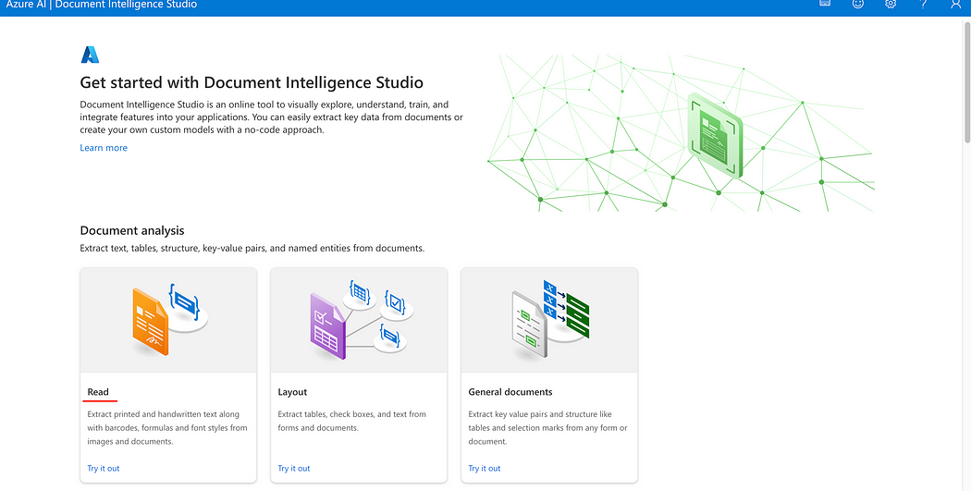

**Step 4: Extract and Download JSON**

Click on *Run Analysis ->*Once this has completed select*Results a*nd download the*JSON* file.

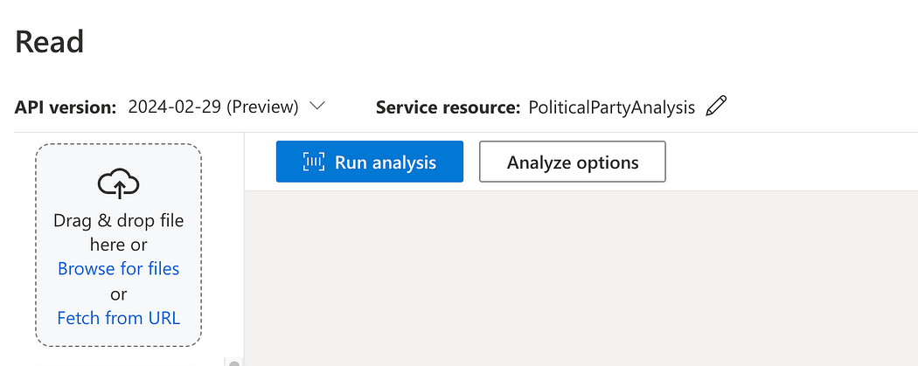

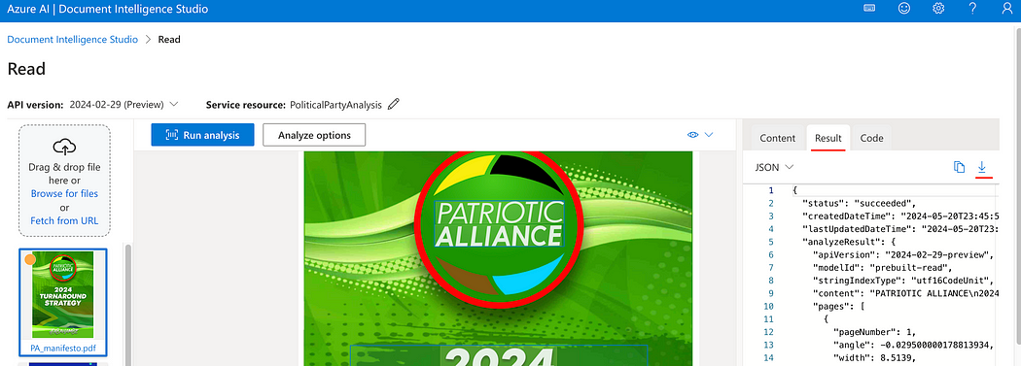

**Creating a Custom Neural Model with Document Intelligence Studio**

1. **Initiate Your Project**: Begin by launching the Document Intelligence Studio. Navigate to the custom models page and click on “Create a Project.” Input your project name and a brief description, then select your Document Intelligence resource.

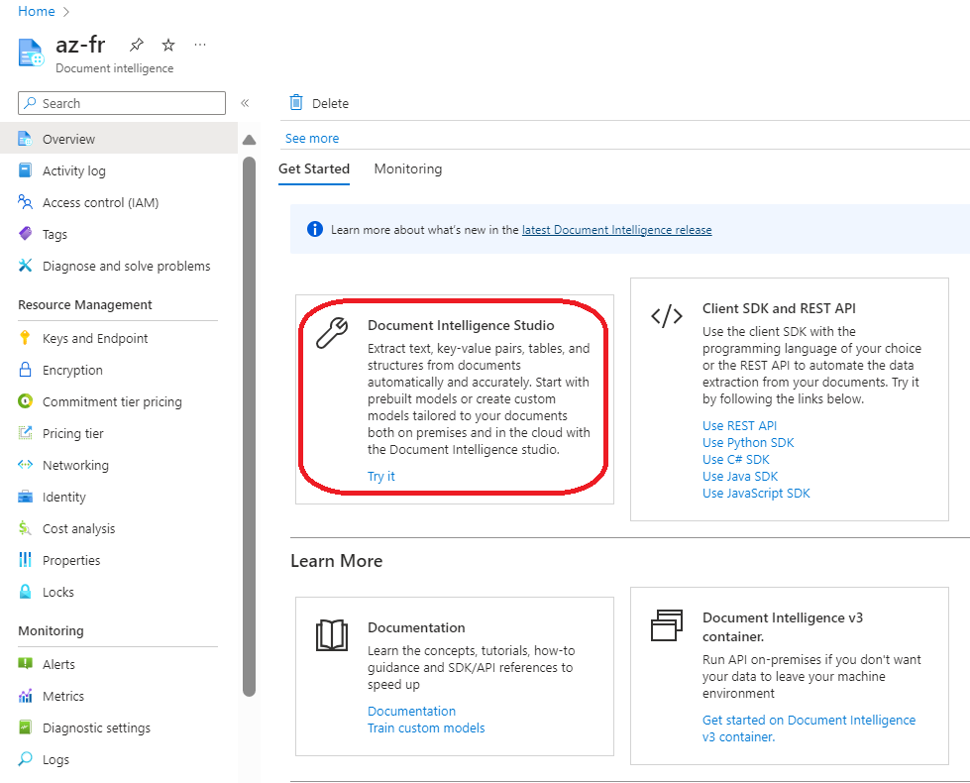

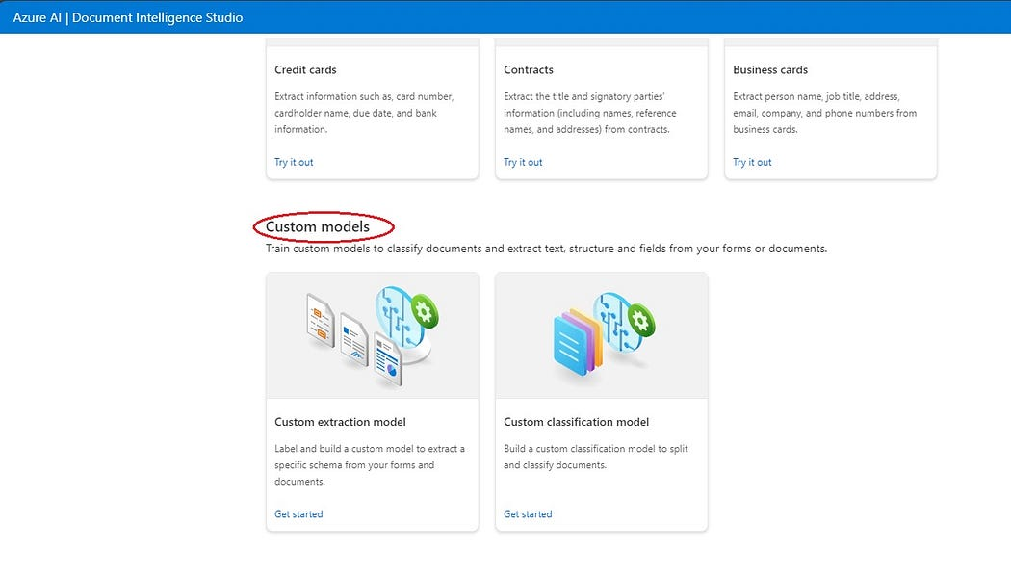

**2. Configure Storage**: Choose a storage account and specify a container. If your documents are directly in the container’s root, leave the Folder path blank. Otherwise, provide the path to your documents within the container. Confirm your settings and create the project.

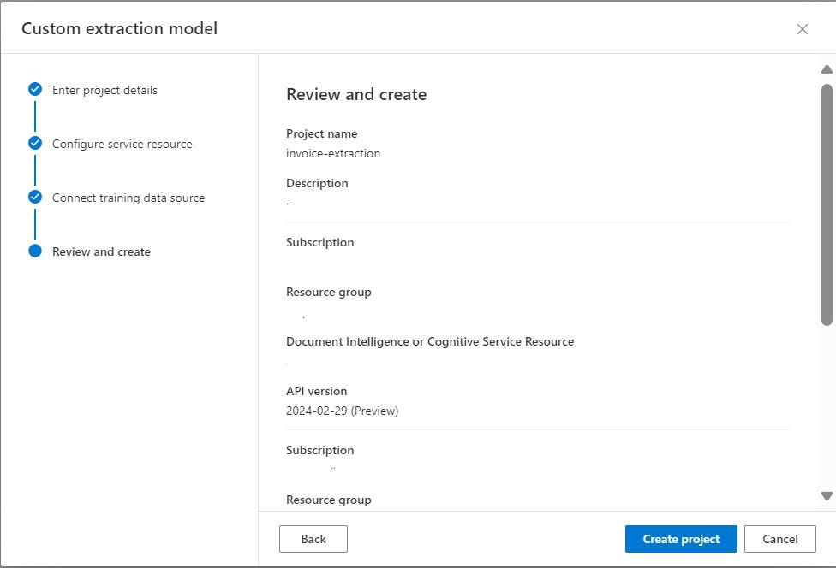

**3. Prepare for Labelling**: Custom models thrive with as few as five training documents. Upload your documents through the labelling window and commence adding fields relevant to your document type.

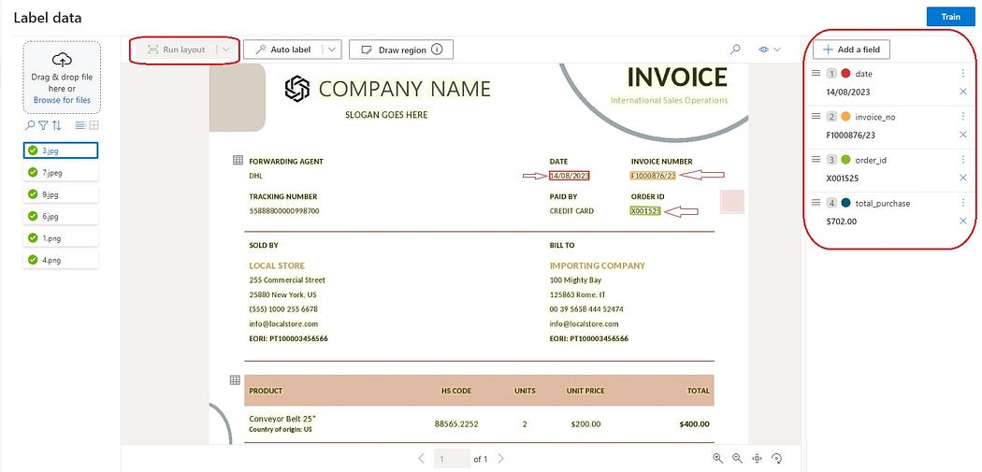

During this phase, a **filename.json** file is automatically generated and stored in your blob storage, serving as the backbone for your model’s understanding of the data structure.

**4. Label Your Data**: This crucial step involves selecting text within your images and assigning it to the appropriate fields you’ve defined. This process must be repeated across all training images to ensure the model learns accurately.

**5. Train Your Model**: Once labelling is complete, initiate model training by clicking the **“Train”** button. Training duration varies but expect it to complete within an hour. Upon completion, the model’s status will update to indicate success.

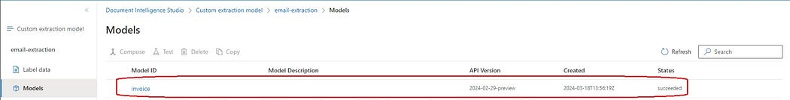

**6. Evaluate the Model**: Test your newly trained model with sample documents by running an analysis. The output will include both the extracted data in your specified fields and a JSON response, providing a comprehensive view of the model’s accuracy.

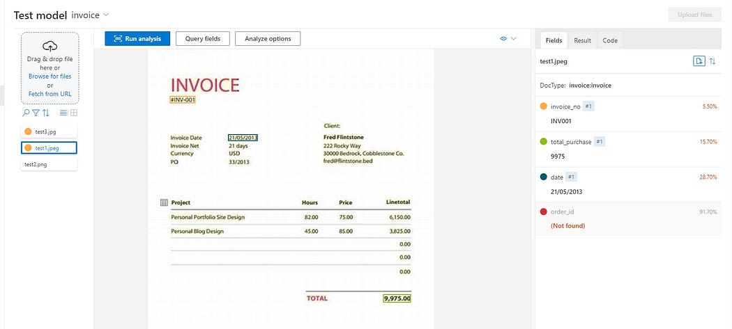

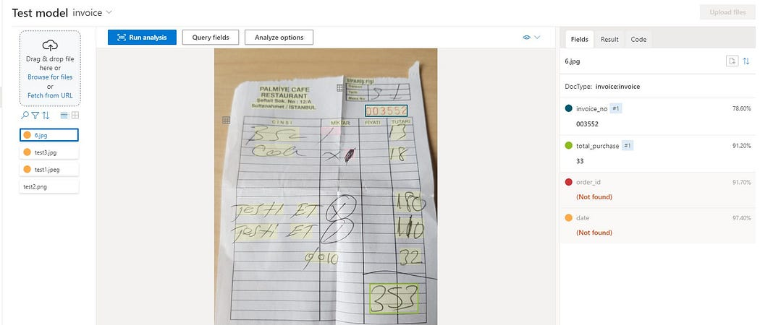

Through this process, your storage account will accumulate several file types crucial for training and evaluation, including original images (.tiff), label information (.tif.labels.json), OCR details (.tif.ocr.json), and the defined field schema (filename.json).

